January 27, 2022 REVISED FORMAT

Secretary-Treasurers

Dear Sisters, Brothers, and Friends:

Re: TABLE OFFICERS’ TRAINING – Spring 2022

Have you recently been elected to a new role on your local executive? If so, congratulations and thank you for your leadership. Many newly elected local officers have participated in Table Officers’ training where they learn the fundamentals on how to fulfill their new role on their local executive.

If your local has not yet held their local elections, please pass this package on after their elections have taken place.

Please note, the March session training will be conducted online via Zoom. We highly recommend participants have access to a working computer or tablet with a built-in camera, microphone and an internet connection.

SESSION | REGISTRATION DEADLINE | REVISED FORMAT | FORMAT
March 30, 31, & April 1, 2022 | February 24, 2022 |  | Online format
April 25, 26, 27, 2022 | March 20, 2022 | ONLINE FORMAT | TBA
May 25, 26, 27, 2022 | April 20, 2022 | ONLINE FORMAT | TBA

Table Officers’ training is offered to Chairpersons, Vice-Chairpersons, Secretary-Treasurers, and Assistant Secretary-Treasurers who, for the first time, are newly elected this year to one of these positions and who have not previously taken this training for that position.

The objectives of this year’s Table Officers’ training are to:

- Provide training and tools to assist Local Officers to effectively fulfill their duties.
- Develop personal and team leadership skills that will help locals become more vibrant and encourage greater membership participation.
- Support locals to build capacity during the challenges of the COVID-19 pandemic, including using virtual tools to run executive and local meetings as well as elections.

Please fill out the attached application form by the indicated deadline and return to the HEU Provincial Office to the attention of Vickie Phillips, Education and Human Rights Department. Please return only ONE copy of the application – either by mail, email to vphillips@heu.org by fax 604-739-1510. Alternatively, an online fillable form is available on our website at www.heu.org.

…/more
We will contact successful applicants by email to confirm further details. Please ensure the email address on your application is current and is your primary email contact where we will send information regarding the workshop. Once applicants have been notified, they will need to apply for Union Leave, where applicable.

If you should have any questions regarding Table Officers’ training, please contact Vickie Phillips by phone: 604-456-7076, toll free: 1-800-663-5813 ext. 7076 or email: vphillips@heu.org.

In solidarity,

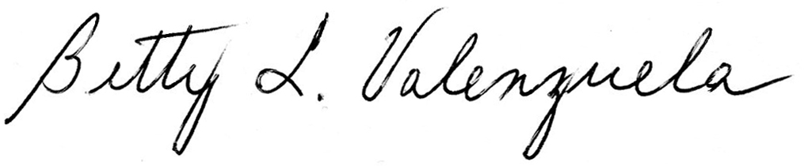

Barb Nederpel Betty Valenzuela
President Financial Secretary

Attachment

cc: Chairperson
Provincial Executive
Reps & Directors

H:\Administration Documents\BGergely\TABLE OFFICERS TRAINING\Table Officers' Training 2022\S-T Table Officers' Training Spring 2022 LTR.docx

