January 27, 2022

Secretary-Treasurers

Dear Sisters, Brothers, and Friends:

Re: Transforming Workplace Conflict Workshop Series 2022

Dealing with conflict at your workplace or within your local union team can be challenging but if addressed effectively, it can lead to greater solidarity. This workshop is for local leaders who want to gain skills and practice techniques to be more effective at transforming conflict.

This online workshop is a combination of HEU’s “Essential Skills for Transforming Workplace Conflict into Union Activism”, paired with Anima Leadership’s “Brave Conversations- Transforming Workplace Conflict”.

During five days of online sessions, through a variety of interactive activities and information sharing, participants will:

- Reflect on ideas and feelings around conflict and how they respond
- Gain a better understanding of different styles for dealing with conflict and identify their go-to style
- Practice skills for deep listening and communicating during conflict
- Explore techniques to respond more effectively during conflict
- Consider the nature and cultural dynamics of conflict
- Explore the role that power and our social identity plays in conflict situations
- Learn about conflict models and use these models to practice moving from positions of interests to generating options for solutions.
- Explore ways of transforming conflicts into union activism
- Play with images, stories and metaphors to navigate conflict
- Have time to rejuvenate and re-energize

…/more
This workshop is made up of five full-day sessions spread out over a four-week period. Participants must be available to attend all five days from 9:30 a.m. – 3:45 p.m.

Session | Location | DATES | Time
Session 1/4 | Online | March 30, 2022 | 9:30 a.m. –3:45p.m.
Session 2/4 | Online | March 31, 2022 | 9:30 a.m. – 3:45p.m.
Session 3/4 | Online | April 7, 2022 | 9:30 a.m. –3:45 p.m.
Session 4/4 | Online | April 14, 2022 | 9:30 a.m. –3:45 p.m.
Session 5/5 | Online | April 21, 2022 | 9:30 a.m. –3:45 p.m.

Please fill out the attached application form and return to the Provincial Office Attention: Deanna Gill, Education and Human Rights Department. Please return only ONE copy of the application – either by mail, email to dgill@heu.org or fax at 604-739-1510 no later than Monday, February 28, 2022. Alternatively, an online form is available on our website at www.heu.org.

We will contact successful applicants by email to confirm further details. Please ensure the email address on your application is current and is your primary email contact where we will send information regarding the workshop. Once applicants have been notified, they will need to apply for Union Leave, where applicable.

If you have any questions regarding this workshop please contact Deanna Gill by phone: 604-456-7165, Toll Free 1-800- 663-5813 local 7165 or email dgill@heu.org.

In solidarity,
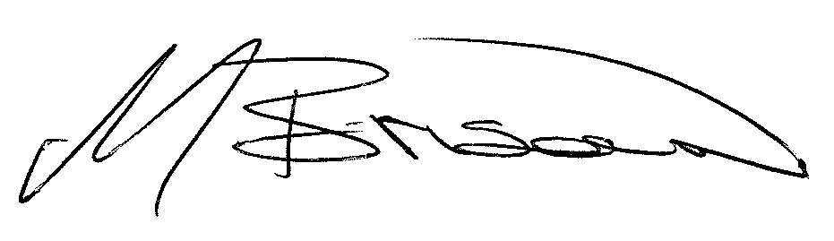

Meena Brisard
Secretary-Business Manager

Attachment

cc: Chairpersons
Provincial Executive
Reps and Directors

H:\Administration Documents\BGergely\Education\S-T Transforming Workplace Conflict LTR 2022.docx

